**Year 11 APPLICATIONS UNIT 2**

**Investigation 3 2020**

**Task weighting 5.5%**

**Due:** **Thursday 29th October 2020**

Name: _____________________________

Measuring What You Cannot See

Relevant syllabus content:

|  |  |
| --- | --- |
| 2.2.3  2.2.4 | **Trigonometry – Non Right Angled Triangles**  solve problems involving non-right-angled triangles using the sine rule (acute triangles only when determining the size of an angle) and the cosine rule  solve practical problems involving non-right-angled triangles, including problems involving angles of elevation and depression and the use of bearings in navigation |

# *Complete the following set of questions by Thursday 29th October.*

* *You are not required to hand in your solutions. Solutions are provided on the last few pages for you to check your answers.*
* *Investigation test is on Thursday 29th October and will be based on the concepts considered in this investigation.*
* *The investigation mark is based solely on the investigation test [5.5% of your school based mark]*

In this investigation, and investigation test you will need

* A ruler
* A protractor
* A compass

Surveying is an important area where trigonometry is utilised. It has many different techniques of mapping out land. There are two main techniques: Triangulation and the Radial Method.

Part A: Triangulation

Triangulation is the method involving the geometrical construction of triangles through the measure of distances and bearings between points.

Consider the situation given two points A and B. We can locate the position of C by either

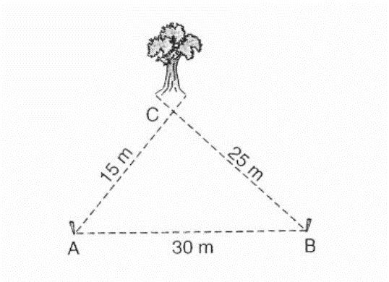

* Measuring the distance from A to C and the distance between B and C.

or

* Measuring the bearing of C from A and the bearing of C from B.

We call the line from A to B the survey line.

This method can be extended to locating positions several landmarks given a survey line AB.

**Question One**

A surveyor recorded the following information.

A survey line AB is 50m long and runs in a north – south direction. A compass is used to measure the angles between the base line and the stations P, Q, R and S. These are given in the table.

|  |  |  |
| --- | --- | --- |
| Station | Bearing from A | Bearing from B |
| P | 110° | 034° |
| Q | 148° | 068° |
| R | 191° | 225° |
| S | 290° | 333° |

1. Draw a scale drawing using the surveyor’s recordings. Use the scale 1mm : 1m.
2. Use trigonometry to determine the length of SR and QR.

Part B: The Radial Method

The radial method uses the following method for surveying a field.

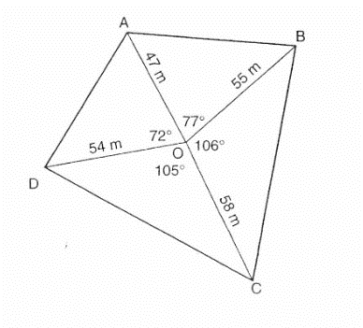

* Choose a point, O, somewhere inside the field
* From point O, determine the bearing of each corner and the distance from point O to each corner.
* Draw a diagram as shown.

**Question Two**

The sketch below is the result of a radial survey of a field.

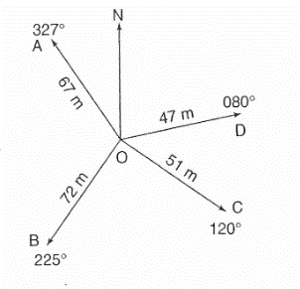

1. Use this sketch to make an accurate scale diagram.
2. Use trigonometry to calculate the perimeter and area of the field.

**Question Three**

The information in the table below is the result of a radial survey.

|  |  |  |
| --- | --- | --- |
| Station | Bearing from O | Distance from O |
| A | 030° | 48 m |
| B | 090° | 56 m |
| C | 220° | 37 m |
| D | 330° | 58 m |

Make a sketch of the field and then use trigonometry to find the perimeter and area.

**SOLUTIONS** – For all diagrams check with your friends and teacher.

1. SR = 75.91m, QR = 43.13m
2. P = 335.91, A = 6352.45m2
3. P = 269.58m, A = 4171.56 m2